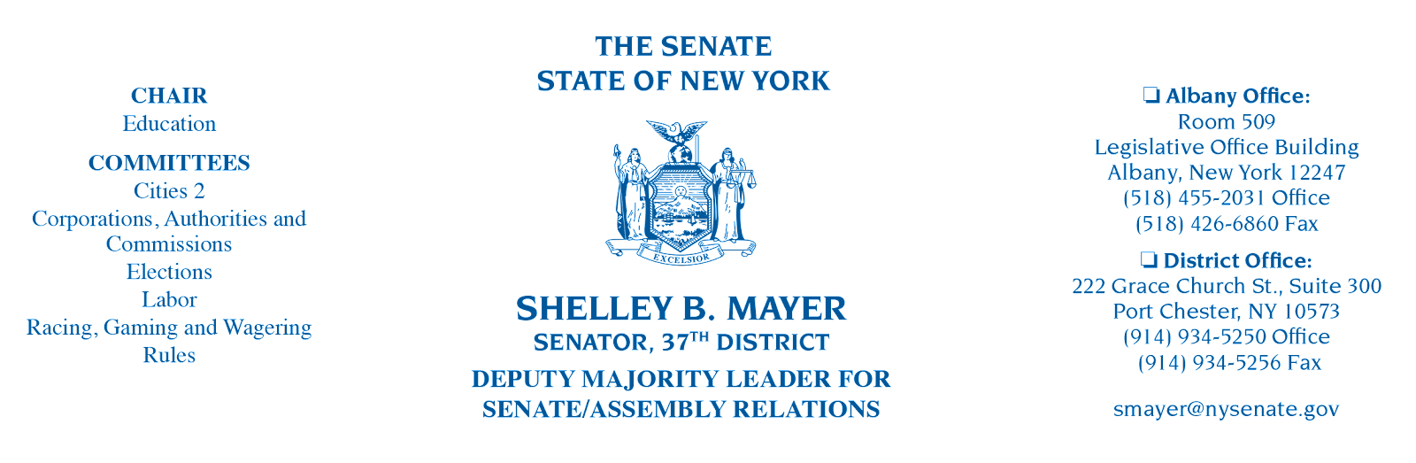

Comments of State Senator Shelley Mayer
On the Climate Action Council’s Draft Scoping Plan

May 12, 2022

We are engaged in this process because of meaningful achievements – the passage of the CLCPA, and the work of the Climate Action Council and its supporting panels and working groups to develop a Draft Scoping Plan that will put us on the path to addressing one of the most pressing challenges of our lifetime, climate change. I am proud that New York State is a leader in this effort nationally, and that as a member of the New York State Senate, I was a co-sponsor of this important legislative achievement.

I want to begin by quoting a statement from the draft scoping plan that I think is critical to keep in mind – “Foundational to the Climate Act and to this Draft Scoping Plan is marrying climate action with equity.” That’s what you have tried to achieve, but there is more we should do. When I learned that there would not be a convenient in-person hearing for many constituents, my colleagues and I took action and petitioned DEC and NYSERDA to make sure another hearing was added to the calendar so that the voices of Westchester and Hudson Valley communities were not left out of this critical discussion.

We stepped up because right here in Westchester, there are communities at great immediate risk from climate change. Sadly, there is a common perception that the communities at greatest risk of the impacts of climate change are not in Westchester, but exclusively in dense urban communities within big cities or in the beach communities of Long Island. That is not the case. Parts of Yonkers, Port Chester, and New Rochelle, among other communities in my district, were identified by the Climate Justice Working Group as “disadvantaged communities” in its draft definition of that term, meaning the residents face such challenges as economic distress, high levels of air pollution, and repeated storms and flooding. It’s essential we hear from these communities and rethink our approach to suburban districts, such as mine, which require us to act responsibly and promptly to address the risks of climate change.

Thanks to the requirement that at least 35% of the benefits of Climate Act investments accrue to “disadvantaged communities,” the state’s implementation of the final scoping plan will mean new sources of assistance for many of my constituents who struggle economically, are at greater risk for pollution-based adverse health outcomes, and are under increasing threat from climate-related natural disasters.

I especially want to commend the work of the Just Transition Working Group. I am deeply committed to ensuring that we take this transition as an opportunity to ensure labor and working-class New Yorkers have newly created opportunities. Climate change must be seen as providing opportunities for meaningful economic growth in all our communities, including prevailing wage and union jobs that will lead to real careers. We ought to be proactive and progressive in this effort, and not just defensive while we transition to the new economy. Good paying new jobs will be created, and we should be at the forefront of that effort.

I recognize some of these goals may seem hard to reconcile. But I know from experience it can be done.

For example, I was deeply involved in the provisions of this year’s Enacted Budget securing the transition to zero-emission school buses. I believe that process can be a model for what the scoping plan seeks to achieve: namely, we heard from all stakeholders and engaged in a dogged process to make sure that schools could afford the buses and infrastructure, that funds were specifically allocated for this purpose, that the state set meaningful standards and timetables for transitioning to zero-emission buses, that plans were in place to ensure that those workers who might be displaced by the policy were not left unemployed, and that no child would lose their ride to school.

Consolidating the various mandates of the Climate Act into a single vision and including all stakeholders – and seizing the opportunity to create meaningful economic growth – is something I believe the Climate Action Council will do thoughtfully and deliberately, and the effort by all involved thus far is highly commendable. It is also clear we’re going to need additional funds to meet the challenges ahead, and that additional legislation and policy development will be necessary to implement the final scoping plan. I look forward to being part of those future efforts.

Thank you for holding these hearings.

