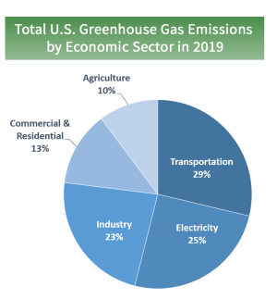

To the Climate Action Council
I have read with great interest on the proposed Draft Scoping Plan for the reduction of greenhouse gases and am deeply surprised by your intentions for this hurried plan to pass in the great state of New York. As I have worked in the HVAC industry for forty years, in western N.Y., I believe requiring the residential and commercial public to change over to electric for their operational and comfort needs is drastic and dangerous
As an instructor/trainer in this field, air quality is not a new issue for me. The global warming issue is not new and is similar to the ozone depletion problem that we had years ago. That problem was addressed globally as the CO2 crisis should be. The above chart was found on an EPA website. So, if residential/commercial accounts for roughly 13% of these emissions, isn’t this like a fly swatter in the barn.
As the “Grid” is above ground and susceptible not only to its age but weather concerns, I cannot believe it is going to be able to handle the massive increase in output for heating that this will place on it. Based on the proposal, people will not be able to generate power, should they lose it. Windmills and solar have not been a proven replacement for power generation
Inverter heat pumps are making great strides in popularity and performance. Achieving comfort and efficiency with a zero CO2 emission is a great direction for the industry to be heading. BUT… we’re not there yet. The expertise for installing and repairing this equipment is new. It will take a little more time. The industry, and others, are seeing supply and material shortages. I’m afraid it’s a little more serious than the toilet paper shortage.
In closing, I urge you to reconsider this Draft Scoping Plan, align with the rest of the country and planet and lets tackle global warming more sensibly. My grandchildren are counting on ya !

Thank you for listening,
Steven Haylett

